**Revision of HR Redemption during renewal process in base premium**

**Team-Renewal operation**

***Functional Requirement Document***

***V2.0***

|  |
| --- |
|  |
|  |

# SCOPE –

This document consist of below changes in HR (Health return) process: -

1 Revision of HR Redemption During Renewal where HR points to be utilize in ~~Base~~ NET premium instead of Gross premium.

1. While creating HR receipt, Jarvis shows the available HR points & to be utilized points as (0).
2. Excess Refund credit note should not generate on health return receipt mode ~~for HRP Utilized policies.~~
3. In case policy is being cancelled then, HR points to be ~~credited~~ Roll back to previous year policy so that same can be utilized if policy is being rebooked.

# Existing Process summary:

## 

**Existing process for Revision of HR Redemption in Jarvis/Customer portal/Seller portal & Policy bazar .**

1. Currently HR (**Health return**) which is earned by a customer as per product feature can be utilized during renewal to reduce the total premium due amount i.e. (net premium +~~tax~~ GST) = gross premium, HR points redemption cannot be more than the net premium.
2. Customer has an option to pay the premium both with redemption of HR points or without HR points through the core system & portals.

**Below is the sample shared for HR scenario.**

|  |  |  |  |  |
| --- | --- | --- | --- | --- |
| Hr Points redemption | |  | Without HR Points | |
| **Net premium** | 15,000 |  | **Net premium** | 15,000 |
| **~~Tax~~ GST** | 2700 |  | **~~Tax~~ GST** | 2700 |
| **Gross Premium** | 17,700 |  | **Gross Premium** | 17,700 |
| **HR points** | 2,000 |  | **Premium payable** | 17,700 |
| **Premium payable** | 15,700 |  |  |  |

**The HR points redemption cannot be more than the net premium**

|  |  |  |  |
| --- | --- | --- | --- |
| Net Premium | ~~20000~~ | 20000 | ~~20000~~ |
| ~~Tax~~ GST | ~~3600~~ | 3600 | ~~3600~~ |
| Gross Premium | ~~23600~~ | 23600 | ~~23600~~ |
| Available HR Points | ~~2000~~ | 21000 | ~~5000~~ |
| HR Receipt | ~~2000~~ | 20000 | ~~5000~~ |
| **Payable Amount** | **~~21600~~** | **3600** | **~~18600~~** |

* System Snap –

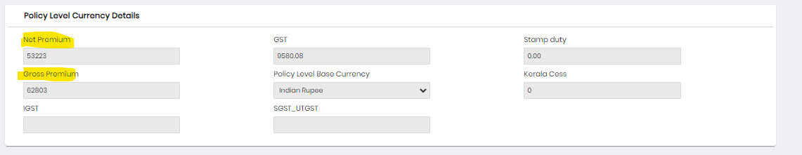

* Customer Portal –

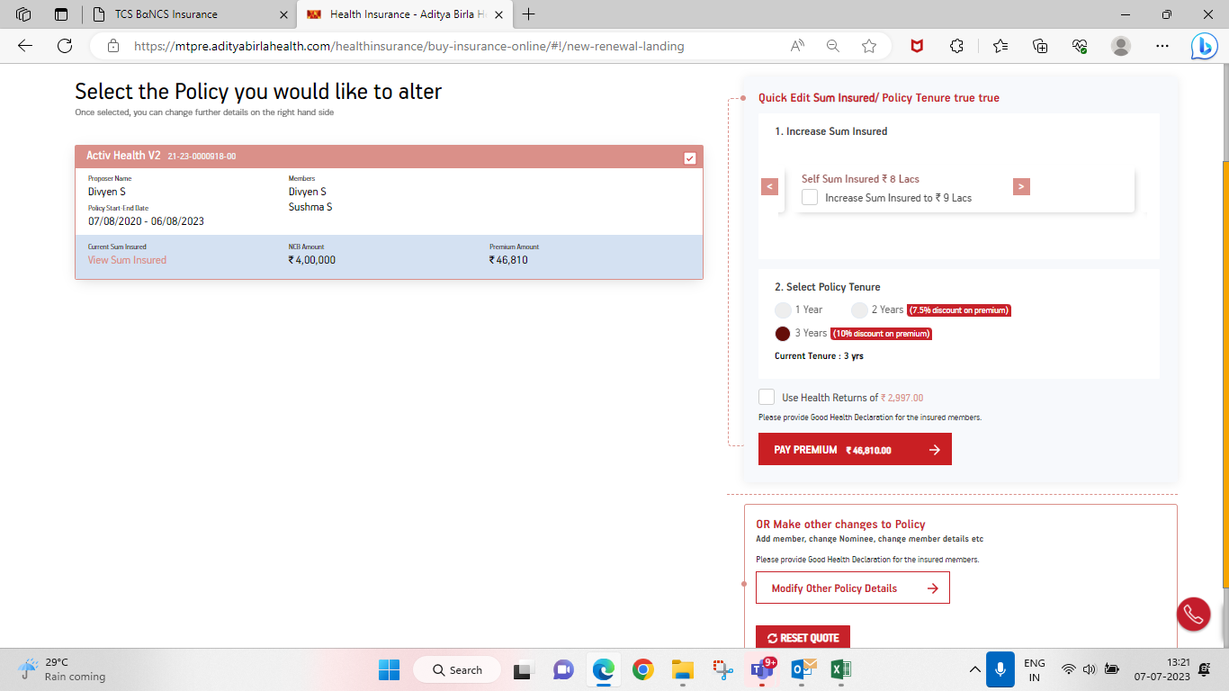

* Seller Portal snap –

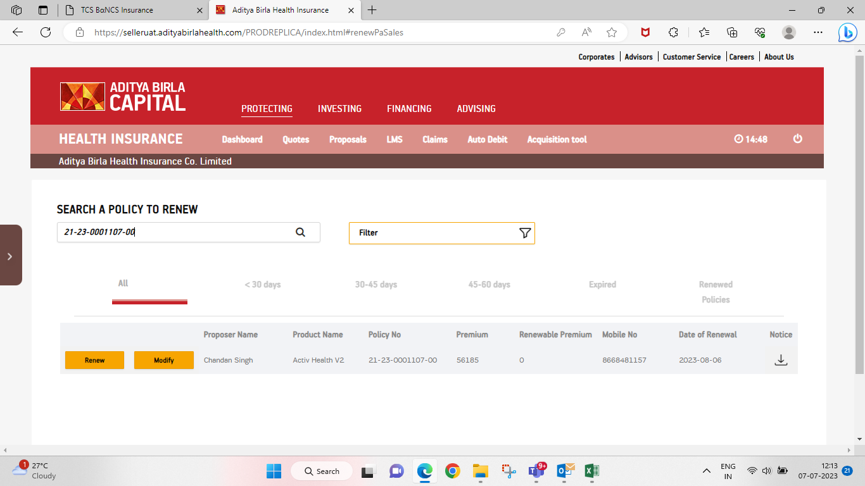

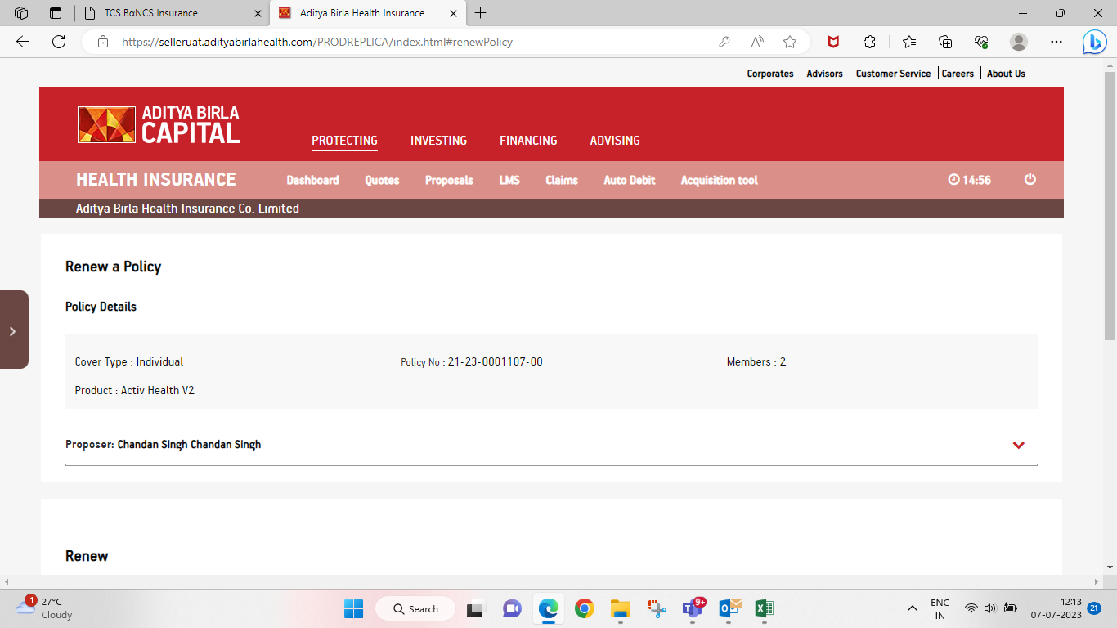

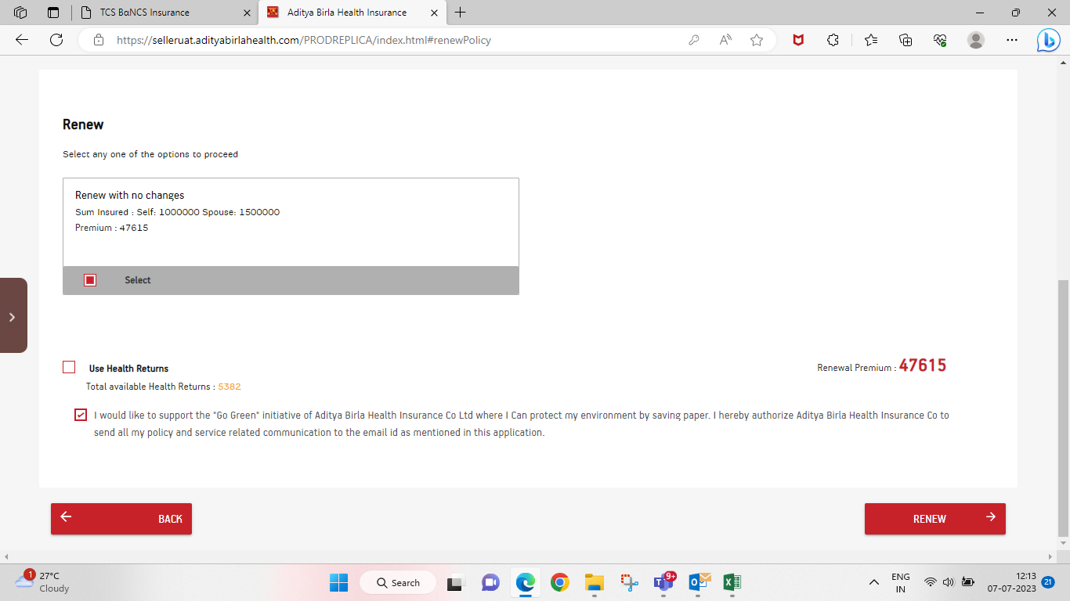

* Health balance accumulated screen

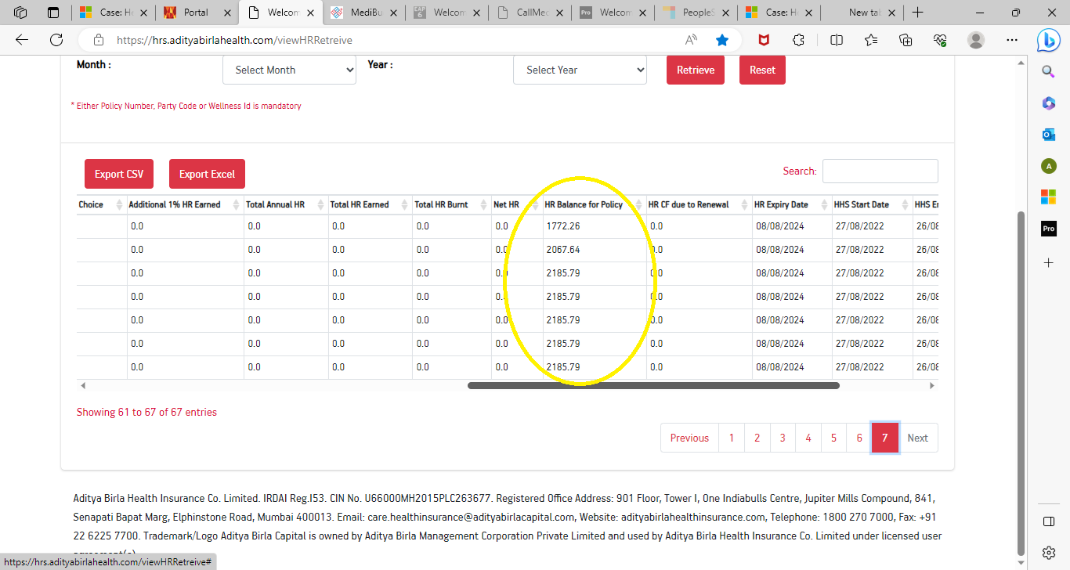

## Current Challenges in process for Revision of HR Redemption in Jarvis:

1. Here HR points needs to be deduct from Net premium instead of Gross premium.
2. Currently HR points is applied on gross premium.

**Revised process for HR Redemption in Jarvis: -**

1) Here HR points need to be deduct from Net premium instead of Gross premium.

2) If policy renewal ~~due~~ NET premium is less than earned health return, then customer can renew his policy by utilizing full health return amount as renewal premium and policy gets renewed in system with customer just paying the GST amount.

3) In the core system this validation should be applicable and same needs to be shared with portal.

### **Existing process while creating HR receipt in Jarvis:**

1. Currently while receipting HR receipt in Jarvis it shows the available HR points & to be utilized points, this screen is set on default mode where available HR points & to be utilized points is same.
2. If customer does not want to utilize his earned HR points, user need to manually remove the HR points from the to be utilized tab.

Below is the screen showing to be utilized & available points.

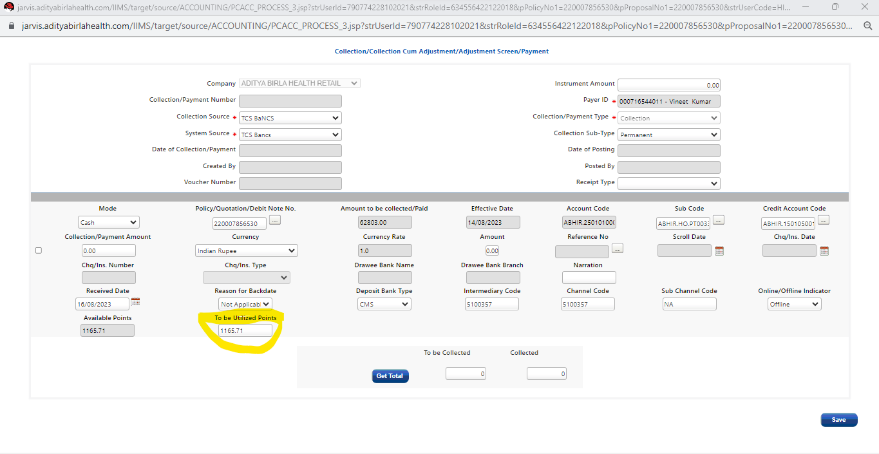 2018

## Current Challenges in process for creating HR receipt in Jarvis: -

1. Currently to be utilized points are shown in Jarvis by default due to which if customer not requested for HRP redemption then by default this value getting added in premium and these leads to excess refund generation.
2. HR points are non-refundable Hence we need to raise service request to roll back HRP points.

**Revised process while creating HR receipt in Jarvis: -**

1. While creating HR receipt, Jarvis will show the available HR points while the to be utilized points will be blank & editable. ~~utilized point should be showing numeric (0)~~
2. **~~User should have the option to manually enter the HR points which the customer wants to redeem~~.** User cannot update “To be utilized points” greater than “Available points”.

**Referring to Ask in point no .1 below is the functionality changes to be made in Jarvis for offline receipting.**

In collection screen, ‘To be Utilized points’ should be ‘blank’ (by default) and the field should be mandatory *(i.e., user cannot proceed further without updating values in the field)*. In case user tries to proceed without any input in ‘to be utilized points’, pop-up error to be displayed mentioning “To be utilized points cannot be blank”.

1. Build validations in values within *‘To be utilized points’* as per the below mentioned logic:
   1. Input values in ‘To be utilized points’ can be only numerical and >= 0.
   2. Users should not be allowed to update ‘To be utilized points’ greater than “Available points. Error message “To be utilized points cannot be greater than available points”.
   3. Users should not be allowed to update ‘To be utilized points’ greater than the ‘Net Premium’ *(i.e., Premium amount excluding GST)* of the policy to be renewed. Error message “To be utilized points cannot be greater than net premium of the policy”.

Refer below mentioned illustration for more clarity:

|  |  |  |
| --- | --- | --- |
| **Particulars** | **INR** | **Logic** |
| Net Premium | 20,000 |  |
| GST | 3,600 | @18% of Net Premium |
| Gross Premium | 23,600 |  |
| Available HR Points *(as per HRS)* | 21,000 |  |
| **Maximum ‘To be Utilized’ allowed** | **20,000** | **<= Net Premium** |
| Therefore, Payable by Customer | 3,600 |  |

**Note:** The validation on point #5 is for offline policy journey. Validation for online journey should be built on respective frontend portals to ensure appropriate collection is done from customers at the time of renewal.

1. In case where ‘to be utilized points’ is input by user, a pop-up notification and confirmation button to be added in below mentioned JARVIS screen when user attempts to save / submit to proceed (i.e., pop-up trigger point will be save / submit button).

Content to be displayed in pop-up notification is as mentioned below:

*“Kindly confirm if you want to redeem the ~~total available~~ HR points <display values input in ‘To be Utilized’ field ~~allowed available points here~~>”*Response Option buttons and corresponding action mentioned below:

|  |  |
| --- | --- |
| **Response** | **Subsequent Action** |
| ‘Yes’ | Allow to proceed with save / submit |
| ‘No’ | Stay on the same page |

Refer below JARVIS screenshot for adding pop-up notification



**Collected total premium check box in Jarvis:**

1. If the to be Collected total premium is either less or higher than the collected total premium, then Jarvis will show an error pop (“Kindly note that value premium/collection value entered is not equal to required premium amount”) message. User should have option to either by pass the error message or correct the value entered in the receipt . Below is the Logic & Text that needs implemented on collection screen.
2. For ‘To be collected’, insert a pop-up alert / notification capturing the below mentioned message:

|  |  |  |
| --- | --- | --- |
| **Logic** | **Text to be displayed in pop-up alert/notification** | **User Response button to be added** |
| Value for ‘To be collected’ < ‘Collected’ | *“Kindly note that value premium/collection value entered is not equal to required premium amount”* | ‘OK’ |
| Value for ‘To be collected’ > ‘Collected’ | *“Kindly note that value premium/collection value entered is not equal to required premium amount”* | ‘OK’ |
| Value for ‘To be collected’ = ‘Collected’ | No alert / pop-up notification required | Not Applicable |

**Note:** User should have option to either bypass the error message or correct the value entered in the receipt, i.e., no restriction required.

Refer below JARVIS screenshot for displaying pop-up notification:

1. **If** the user ~~rectifies~~ Cross check the receipt value, ~~then the click on the Get Total button should be mandatory to confirm total receipting value.”~~ Click on get total button is not mandatory~~”~~

# **C) Existing process for HRP Utilized policies in Jarvis & wellness (HR portal):**

1. Currently policies which gets renewed with HR (Health return points) points, post renewal if active policy gets cancelled due to IT issue/Data entry error/finance, then user have to process for re-login.

While re-login policy, user need to raise service request to wellness team or roll back of HR (Health return points) to previous policy which was utilized in ~~renewal~~ Renewed process. Once HR (Health return points) roll backs to previous policy then user is able to utilize the same while re-login the policy.

**Post policy cancelation user raise request to wellness team for roll back HRP ( Health return point) to parent policy**

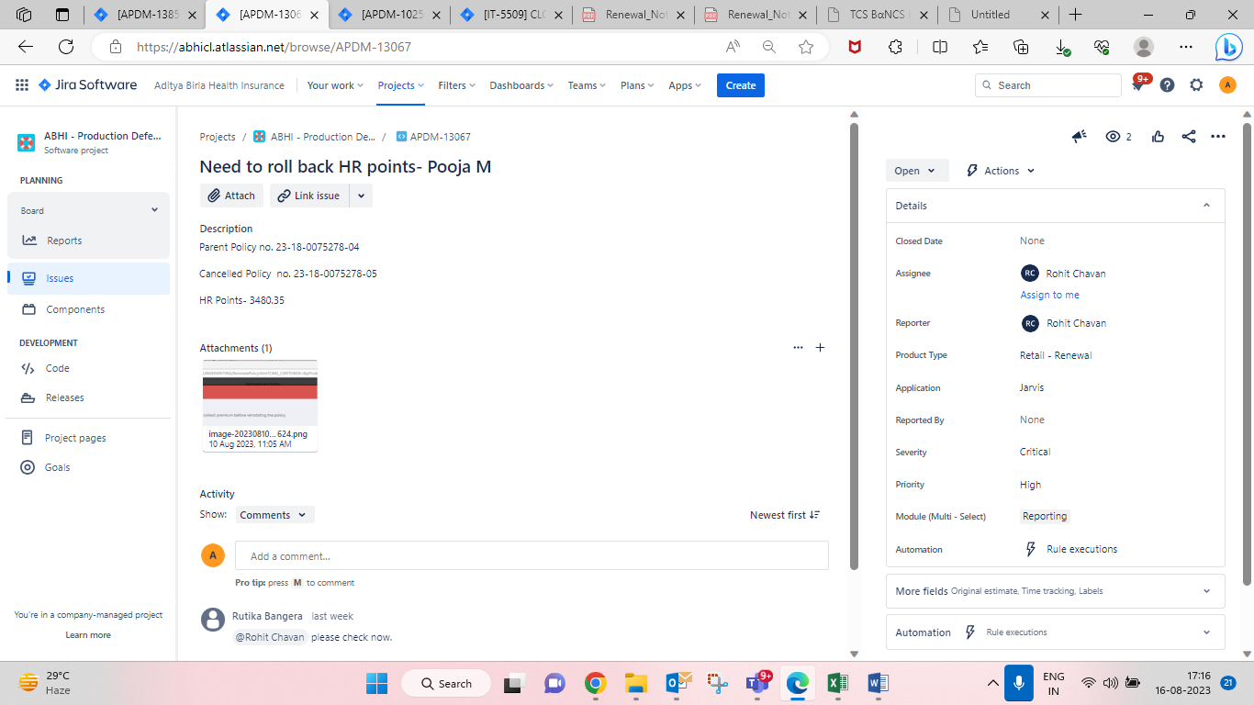

## Current Challenges in process for HRP Utilized policies: -

1. HR points are non-refundable hence user need to raise service request to roll back HRP (Health return points) every time manually.
2. User getting shortfall while re-login the policy

**Revised process for HRP Utilized policies: -**

1. In case policy is being cancelled then the credit note should generate without HRP points , HR points to be ~~credited~~ Roll back to previous year policy so that same can be utilized if policy is being rebooked.
2. For cancelled policy HR utilized points to be mention as “0” (System-Jarvis)

3 As HR points are non-refundable, policy Refund should get generated as per existing BAU process.

4 Refund generated after cancellation communication should be send to net payable amount. (Click Pss)

**Current** **BAU process:-**

**EX:**

* 1. If customer paid full premium along with HR points then, differential amount paid by customer to be refund. For instance, due premium is 1000 & customer paid 1000 via online payment and utilized 100 HR points then HR points to be considered of 100 RS against which refund to be generated out of the 1000 Rs paid by customer via online payment.
  2. Refund should not generate for Health Return receipt

# USERS-

* RENEWAL OPERATIONS
* REFUND
* WELLNESS
* ABHI BRANCH OPS

# PROPOSED PROCESS.

## Products

* + All product compromising retail.

## Channel

* + All channel

## IT Application:

* -Jarvis
* -ESB
* -CRM
* -HR portal (wellness)
* Click PSS (Communication SMS)

# SYSTEM INTEGRATION –

Integration will be wrt Jarvis core system, ESB

Below are the Impacted Systems:

-Jarvis

- ESB

- Wellness system

- Customer portal

- Seller Portal

- Policy Bazar Portal

# USE CASES WITH USER FLOWS –

1. **Scenarios to be tested on Jarvis for HR redemption while renewal: -**

* HR (Health return) redemption to be utilized on net premium instead on gross of premium in Jarvis/Customer Portal/Seller Portal & Policy bazar .

**2 Scenarios to be tested on HR receipting in Jarvis:**

* While creating HR receipt, Jarvis will show the available HR points while the to be utilized points will be blank & editable
* User will have the option to manually enter the points which the customer wants to redeem

**3 Scenarios to be tested on HRP Utilized policies:**

In case if renewed policy is cancelled then accumulated HR pointsneeds to be rolled back to previous year policy (In HR portal) so that same can be utilized if policy is being rebooked. And in Jarvis to be utilized HR points to be shown as (0) at collection screen.

**4 )** **Refund should not generate for Health Return receipt**

* + If customer paid full premium along with HR points then, differential amount paid by customer to be refund. For instance, due premium is 1000 & customer paid 1000 via online payment and utilized 100 HR points then HR points to be considered of 100 RS against which refund to be generated out of the 1000 Rs paid by customer via online payment.

# ASSUMPTIONS –

1. All the suggested changes should follow Product and underwriting guidelines of respective product as per ongoing process.
2. The renewing policy should be a split policy where policy type is family floater & covered kid should be completing 25 years of age at the time of policy renewal.
3. Split policy gaudiness to be applicable for covered products.
4. Policies other than split, will work as per ongoing process.
5. All the communication should get triggered as per ongoing process.

# DEPENDENCIES –

NA

# OPEN POINTS FOR DISCUSSION –

# OUT OF SCOPE –

* WITHOUT HEATLH RETURN POLICIES, RUG & GROUP polices

# ANNEXURE –

|  |  |  |
| --- | --- | --- |
| **Sr no.** | **Description** | **Attachment** |
|  | CR Document |  |
|  | Product Construct |  |
|  | UW Rules |  |
|  |  |  |
|  |  |  |
|  |  |  |
|  |  |  |

# **Addendum**

This section outlines the business requirements related to the handling of Health Returns (HR) in the event of policy cancellation, rebook & reinstated

## **11.1 In Scope**

* HR behaviour on policy cancellation
* HR rollback in rebooking and reinstatement scenarios
* Accrued and unclaimed HR remains available for claim up to ~~3~~ 6 months (configurable) post cancellation.

## **Out of Scope**

**Below Edge cases to be Handled offline:**

* + If policy is cancelled and is being reinstated after 6 month for exception cases like this solutions will be provided based on individual requests
  + If policy is cancelled and reinitiated but the policy start date gets changed, such cases will be handled offline

## **Functional requirement**

* + 1. **HR Rollback Cancelled and Rebook**

**HRS System should:**

* Roll back unutilized HR
* Roll back HR utilized during renewal
* Roll back HR earned before cancellation of the policy
* **Example:**

1. User has 1000 HR points.  
2. In Jan, uses 400 points to renew policy (600 remaining).  
3. Earns 100 points in Jan  
4. Earns 100 points in Feb  
5. Policy is cancelled in March.  
6. HRS rolls back utilized 400 points used in Jan.  
7. Final balance is 1200 HR points.( 600 unutilized HR+ utilized 400 + 200 HR earned in Jan & Feb)

## **11.3.2 Company initiated & Customer initiated**

**HRS System should:**

* Roll back unutilized HR
* Roll back HR utilized during renewal. HR points will not be refunded in this case.
* **Example:**

1. User has 1000 HR points.  
2. In Jan, uses 400 points to renew policy (600 remaining).  
3. Earns 100 points in Jan  
4. Earns 100 points in Feb  
5. Policy is cancelled in March.

1. ~~HRS will not rolls back utilized 400 points used in Jan.~~
2. Final balance is 800 HR points

**11.3.2.1 Policy reinstated:**

* Roll back HR earned before cancellation
* **Example:**

Final balance after policy is reinstated is 1200 HR points.( 600 unutilized HR+ utilized 400 + 200 HR earned in Jan & Feb)

* + 1. **Net Premium Refund Amount**

Refund Amount on Pre cancellation screen should be calculated without HR points& credit note for refund should generate without HR points.

1)Company initiated

2)Customer initiated

**Adding correct screenshot for cancel and refund (customer and company induced)**

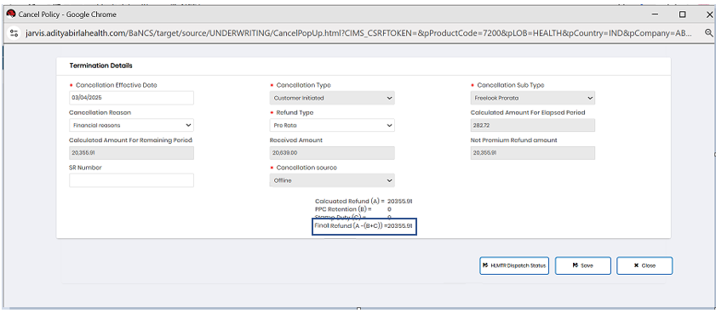

3) Cancel & rebook Pre cancellation screen should display full refund amount.

* 1. **Functional Requirements**

| **ID** | **Requirement Description** | **Source System** |
| --- | --- | --- |
| FR-01 | Trigger from Jarvis on cancellation with cancellation type and initiator | Jarvis/AIS |
| FR-02 | Compute HR expiry date post-cancellation | HRS |
| FR-03 | Reflect HR expiry on Activ App | HRS |
| FR-04 | Enable rollback of HR for reinstatement/rebook | HRS |
| FR-05 | Exclude HR from refund calculation in Jarvis Pre-Cancellation screen | Jarvis |

Rollback Scenarios

A. Policy Cancellation Scenarios

Full HR Rollback: Triggered when a policy is cancelled and no fresh HR is generated under a new policy.

Partial HR Rollback: If fresh HR is generated under a new policy, rollback is only applicable for the non-migrated portion.

B. Member-Level Endorsement Scenarios

Deceased Member: HR rollback is done only for the deceased member.

Member Removed from Policy: HR rollback is done for the removed member alone.